- Launch one aws ec2 and install jenkins.
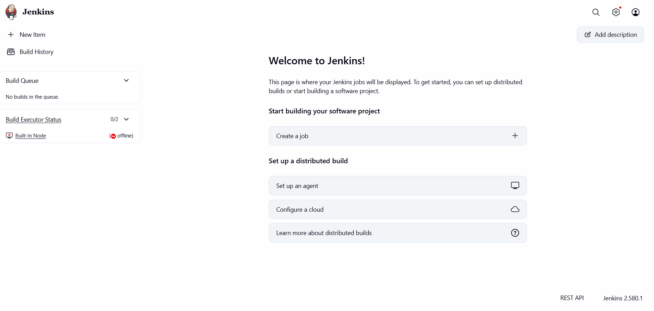
2.Setup Apache Tomcat on Ubuntu Virtual Machine
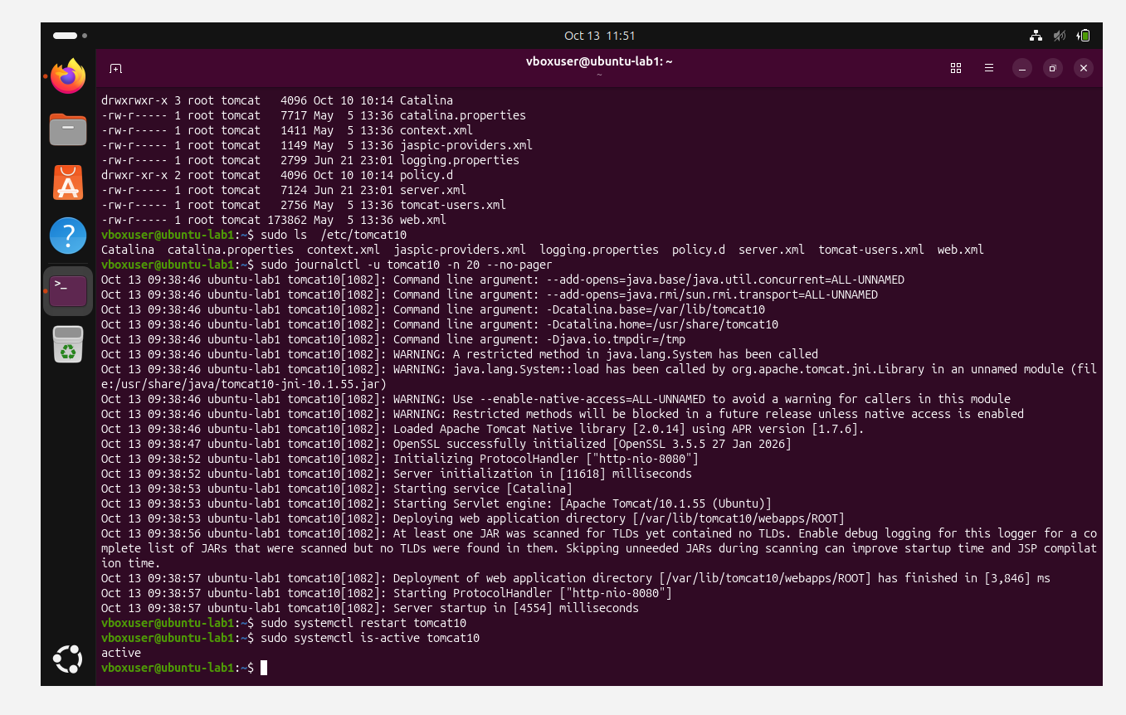
3.Setup Docker Desktop on your local windows.

